Practical 4 | AO* ALGORITHM | Date: 25/07/2025
Aim: | To implement AO* Algorithm on given graph
Requirement: | Python IDE
Code: | 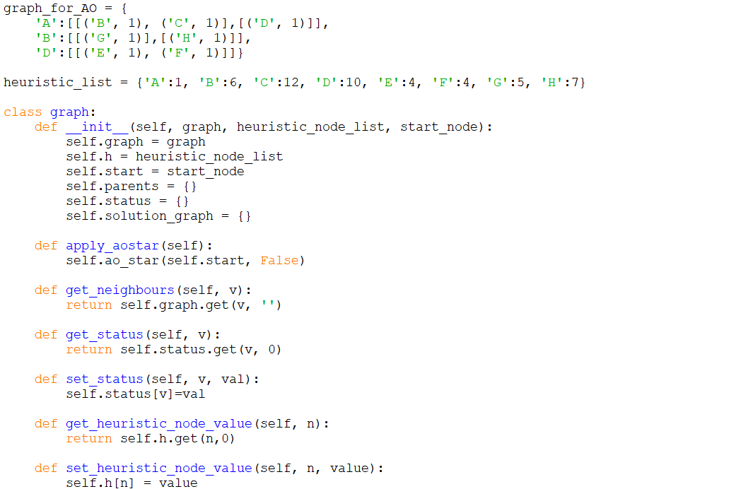  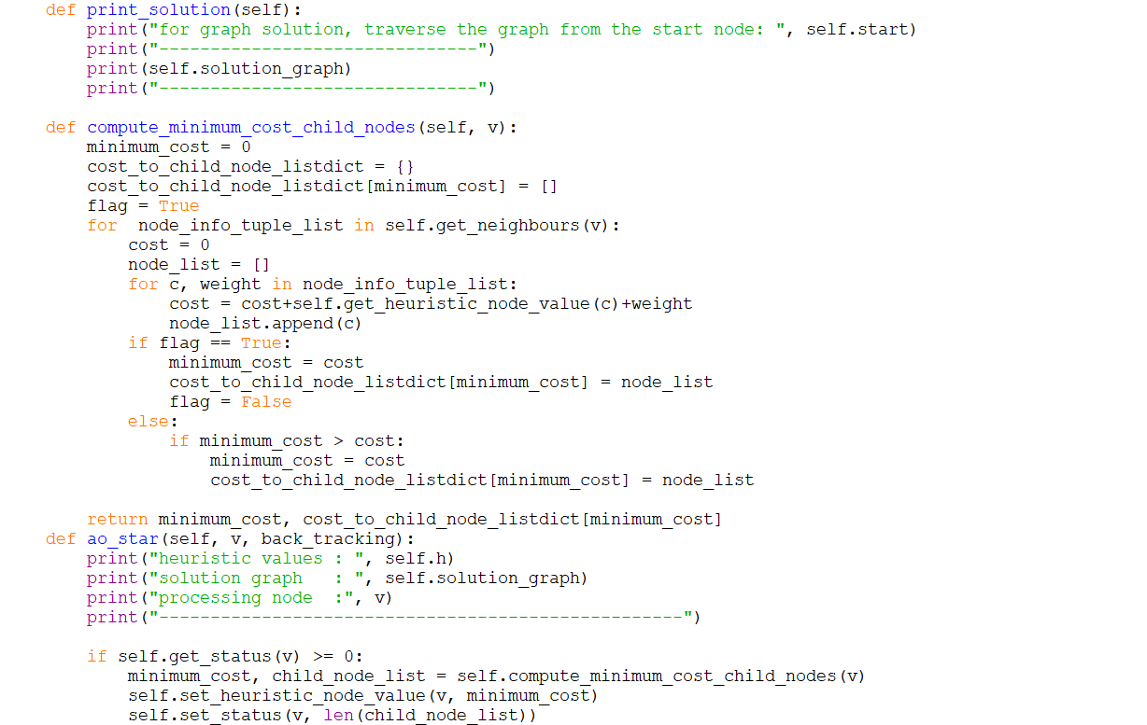  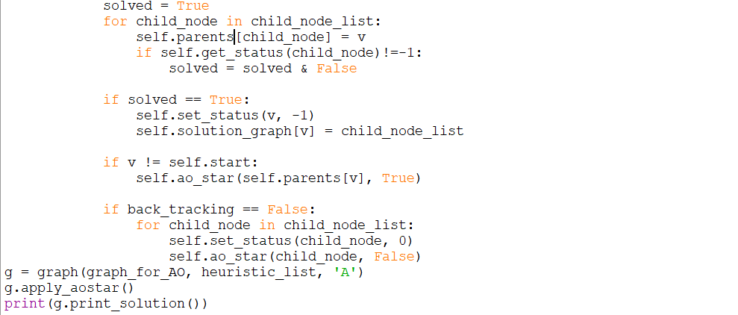
Screenshots: | 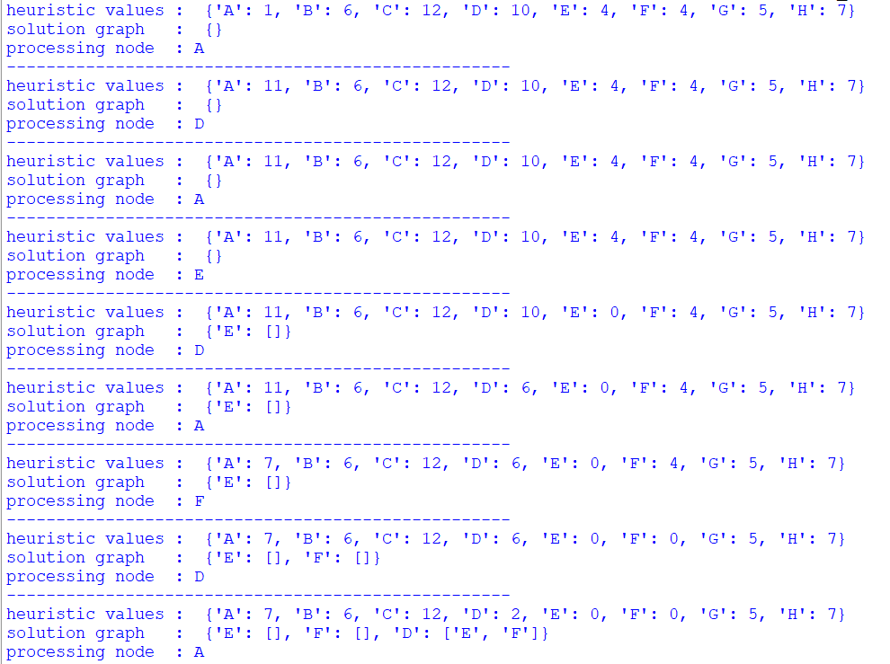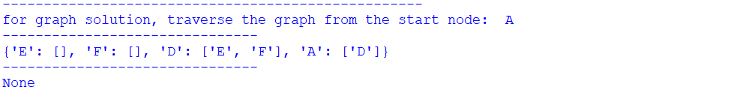
Result: | AO* Algorithm has been implemented using python.
Date of Submission: |  | Sign:

